**AI Generated DAX**

Quick measure suggestions assist creation of DAX measures using natural language instead of using templates or writing DAX from scratch.

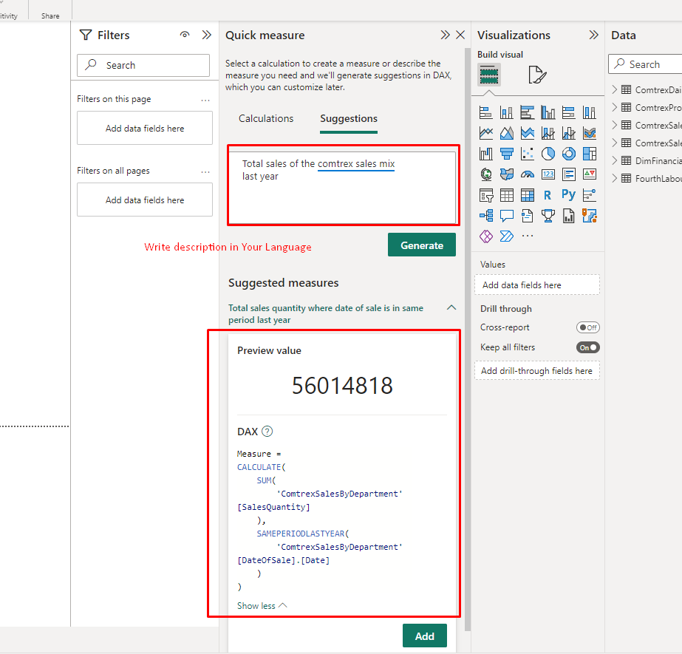

--> This feature can be used to jump-start creation of common DAX measures scenarios such as:

* Selected value
* If condition
* Text operations
* Time intelligence
* Relative time filtered value
* Most / least common value
* Top N filtered value
* Top N values for a category
* Information functions

& Many More .

## How To **Enable measure suggestions**

1. Goto -> File ->Options& Setting ->Options -> Preview Features -> Quick Measure Suggestion
2. Then Click on Quick Measure in Home Tab

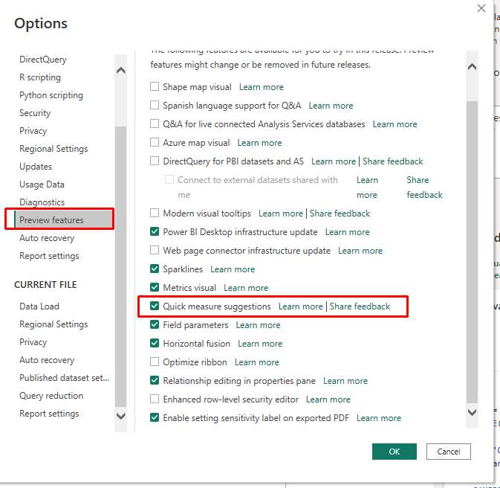

Examples

* Show me sum of sales
* Total sold units in 2022
* Count records of sales table
* Count rows of sales table where Product is Word and Region is North
* Average sales per store
* Sales / target revenue * 100
* What is the selected product
* If sales > 10,000 return "high sales" else "low sales"
* YTD sales
* Unique users in the last 4 hours
* Total sales for the top 3 products

Limitation & Considerations

1. Not a Replacement of Dax Learning , it just helps you to fast track measure creation.
2. The feature is powered by a machine learning model that is currently only deployed to US datacenters (East US and West US). If your data is outside the US, the feature will be disabled by default unless your tenant admin enables ****Allow user data to leave their geography tenant setting****:

